Credit Risk Assessment & Early Warning System

( SQL-Based Project)

Tools & Methodology
SQL (Google BigQuery)

Dataset
UCI Credit Card Default Dataset(Kaggle)

Contact Details:
megha9752@gmail.com

INDEX

Sr No. | Particulars | Pg No.
1 | Project Overview | 3
2 | Data Quality Checks | 4
3 | Data Preparation & Cleaning | 8
4 | Risk Profiling by Demographics | 12
5 | Behaviour Risk and Delinquency Analytics | 21
6 | Behaviour Scorecard and Risk score Grading | 30
7 | Exposure at Default & Value at Risk | 32
8 | Key insights | 37
9 | Risk Mitigation | 38
10 | Conclusion | 39

1. PROJECT OVERVIEW

This project develops a SQL driven Credit Risk Monitoring and Early Warning System for a retail credit card portfolio using behavioural, demographic, and exposure-based analytics.The objective is to identify high-risk customer segments, quantify exposure at default, and detect early signs of financial stress before formal delinquency, This dataset contains information on default payments, demographic factors, credit data, history of payment, and bill statements of credit card clients in Taiwan from April 2005 to September 2005 of around 3000 customers.

1.1 Data Overview
There are 25 variables:
- ID: ID of each client
- LIMIT_BAL: Amount of given credit in NT dollars (includes individual and family/supplementary credit
- SEX: Gender (1=male, 2=female)
- EDUCATION: (1=graduate school, 2=university, 3=high school, 4=others, 5=unknown, 6=unknown)
- MARRIAGE: Marital status (1=married, 2=single, 3=others)
- AGE: Age in years
- PAY_0: Repayment status in September, 2005 (-1=pay duly, 1=payment delay for one month, 2=payment delay for two months, ... 8=payment delay for eight months, 9=payment delay for nine months and above)
- PAY_2: Repayment status in August, 2005 (scale same as above)
- PAY_3: Repayment status in July, 2005 (scale same as above)
- PAY_4: Repayment status in June, 2005 (scale same as above)
- PAY_5: Repayment status in May, 2005 (scale same as above)
- PAY_6: Repayment status in April, 2005 (scale same as above)
- BILL_AMT1: Amount of bill statement in September, 2005 (NT dollar)
- BILL_AMT2: Amount of bill statement in August, 2005 (NT dollar)
- BILL_AMT3: Amount of bill statement in July, 2005 (NT dollar)
- BILL_AMT4: Amount of bill statement in June, 2005 (NT dollar)
- BILL_AMT5: Amount of bill statement in May, 2005 (NT dollar)
- BILL_AMT6: Amount of bill statement in April, 2005 (NT dollar)
- PAY_AMT1: Amount of previous payment in September, 2005 (NT dollar)
- PAY_AMT2: Amount of previous payment in August, 2005 (NT dollar)
- PAY_AMT3: Amount of previous payment in July, 2005 (NT dollar)
- PAY_AMT4: Amount of previous payment in June, 2005 (NT dollar)
- PAY_AMT5: Amount of previous payment in May, 2005 (NT dollar)
- PAY_AMT6: Amount of previous payment in April, 2005 (NT dollar)
- default.payment.next.month: Default payment (1=yes, 0=no)

1.2 Data view
SELECT *
from `credit_risk.customer_dataset`
limit 15;

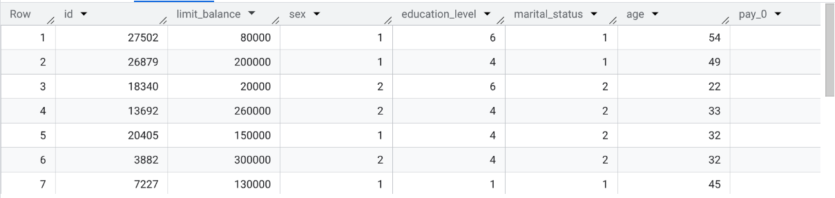

2. DATA QUALITY CHECKS

2.1 Missing Values

Row missing_limit missing_age
1 0 0
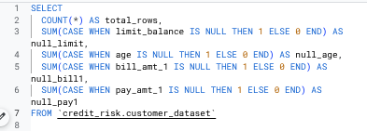
Output:
Row total_rows null_limit null_age null_bill1 null_pay_1
1 2965 0 0 0 0

2.2 Demographics of the Database( Sex)

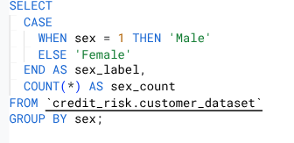
Output:
Row sex_label sex_count
1 Male 1163
2 Female 1802

2.3 Average Values of the Dataset

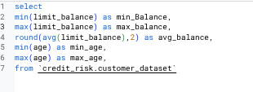
Output:
Row min_Balance max_balance avg_balance min_age max_age
1 10000 800000 163369.31 21 69

2.4 Repayment Status Spread at pay_0( month 1)
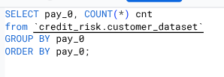

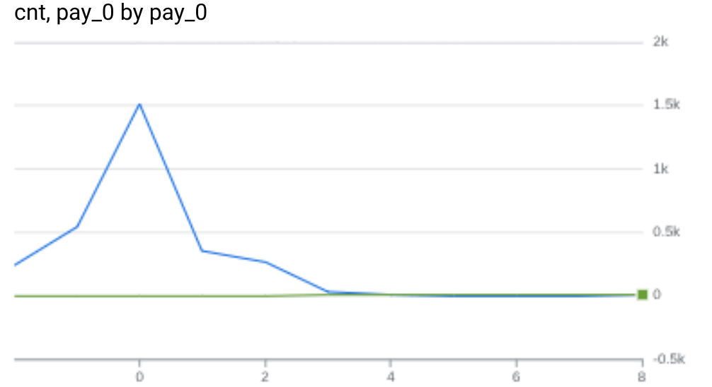

2.5 Monthly billing behaviour
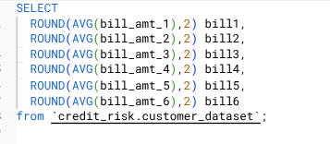

Output :
Row bill1 bill2 bill3 bill4 bill5 bill6
1 52118.31 50649.15 48239.76 44089.68 40956.08 39773.07

2.6 Payment Behaviour

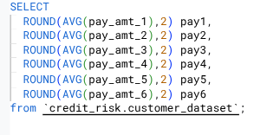
Output:
Row pay1 pay2 pay3 pay4 pay5 pay6
1 6348.9 6272.49 5150.5 4561.38 4913.29 5382.7

2.7 Identify Delinquent Customers
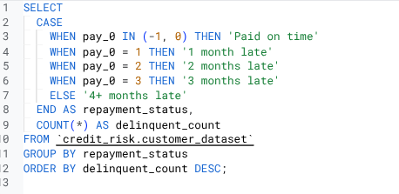
Output:
Row repayment_status delinquent_count
1 Paid on time 2056
2 1 month late 356
3 2 months late 262
4 3 months late 29
5 4+ months late 262

2.8 Segment by Credit Limit Bands
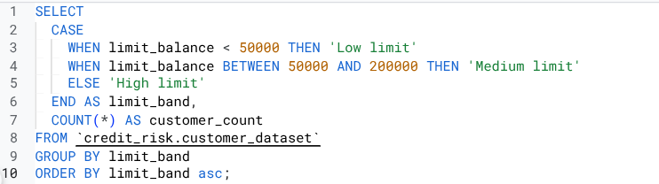
Output:

Row limit_band customer_count
1 High limit 930
2 Low limit 423
3 Medium limit 1612

3. Data Preparation & Cleaning

CREATE OR REPLACE TABLE `credit_risk.customer_risk AS
SELECT
id,
limit_balance,
CASE
WHEN education_level = 1 THEN 'Graduate School'
WHEN education_level = 2 THEN 'University'
WHEN education_level = 3 THEN 'High School'
ELSE 'Others'
END
AS education_status,
CASE
WHEN marital_status = 1 THEN 'Married'
WHEN marital_status = 2 THEN 'Single'
ELSE 'Others'
END
AS marriage_status,
CASE
WHEN age BETWEEN 21 AND 30 THEN 'Young adults'
WHEN age BETWEEN 41 AND 50 THEN 'Middle Aged'
ELSE 'Senior adults'
END
AS age_category,
case
when sex = 1 then 'Male'
when sex = 2 then 'Female'
else 'Others'
end as Gender,
CASE
WHEN pay_0 = -2 THEN 'no consumption'
WHEN pay_0 = -1 THEN 'paid'
WHEN pay_0 = 0 THEN 'minimum paid'
WHEN pay_0 = 1 THEN 'one month delay'
WHEN pay_0 = 2 THEN ' two month delay'
WHEN pay_0 = 3 THEN 'three month delay'
WHEN pay_0 = 4 THEN ' four month delay'
ELSE ' extremely delayed'
END
AS sept_repayment,
CASE
WHEN pay_2 = -2 THEN 'no consumption'
WHEN pay_2 = -1 THEN 'paid'
WHEN pay_2 = 0 THEN 'minimum paid'
WHEN pay_2 = 1 THEN 'one month delay'
WHEN pay_2 = 2 THEN ' two month delay'
WHEN pay_2 = 3 THEN 'three month delay'
WHEN pay_2 = 4 THEN ' four month delay'
ELSE ' extremely delayed'
END
AS august_repayment,
CASE
WHEN pay_3 = -2 THEN 'no consumption'
WHEN pay_3 = -1 THEN 'paid'
WHEN pay_3 = 0 THEN 'minimum paid'
WHEN pay_3 = 1 THEN 'one month delay'
WHEN pay_3 = 2 THEN ' two month delay'
WHEN pay_3 = 3 THEN 'three month delay'
WHEN pay_3 = 4 THEN ' four month delay'
ELSE ' extremely delayed'
END
AS july_repayment,
CASE
WHEN pay_4 = -2 THEN 'no consumption'
WHEN pay_4 = -1 THEN 'paid'
WHEN pay_4 = 0 THEN 'minimum paid'
WHEN pay_4 = 1 THEN 'one month delay'
WHEN pay_4 = 2 THEN ' two month delay'
WHEN pay_4 = 3 THEN 'three month delay'
WHEN pay_4 = 4 THEN ' four month delay'
ELSE ' extremely delayed'
END
AS june_repayment,
CASE
WHEN pay_5 = -2 THEN 'no consumption'
WHEN pay_5 = -1 THEN 'paid'
WHEN pay_5 = 0 THEN 'minimum paid'
WHEN pay_5 = 1 THEN 'one month delay'
WHEN pay_5 = 2 THEN ' two month delay'
WHEN pay_5 = 3 THEN 'three month delay'
WHEN pay_5 = 4 THEN ' four month delay'
ELSE ' extremely delayed'
END
AS may_repayment,
CASE
WHEN pay_6 = -2 THEN 'no consumption'
WHEN pay_6 = -1 THEN 'paid'
WHEN pay_6 = 0 THEN 'minimum paid'
WHEN pay_6 = 1 THEN 'one month delay'
WHEN pay_6 = 2 THEN ' two month delay'
WHEN pay_6 = 3 THEN 'three month delay'
WHEN pay_6 = 4 THEN ' four month delay'
ELSE ' extremely delayed'
END
AS april_repayment,
bill_amt_1 AS sept_due,
bill_amt_2 AS august_due,
bill_amt_3 AS july_due,
bill_amt_4 AS june_due,
bill_amt_5 AS may_due,
pay_amt_6
AS april_due,
CASE
WHEN default_payment_next_month = 1 THEN 'defaulted next month'
ELSE 'did not default'
END
AS default_status
FROM `credit_risk.customer_dataset`;

Output:
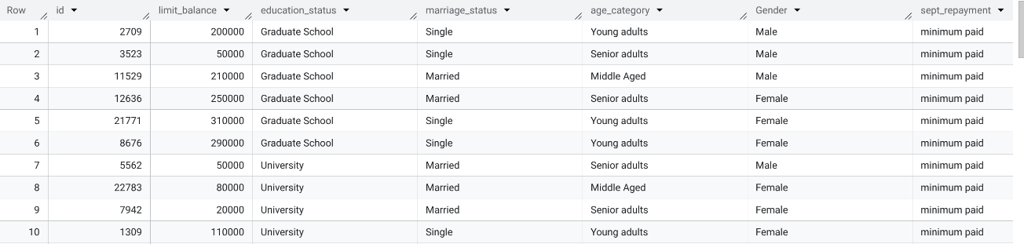
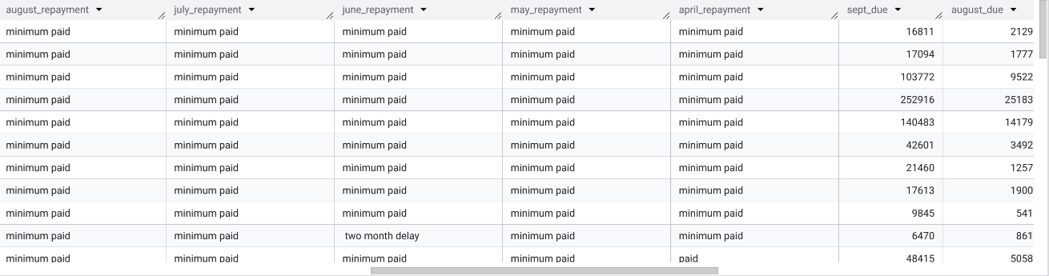
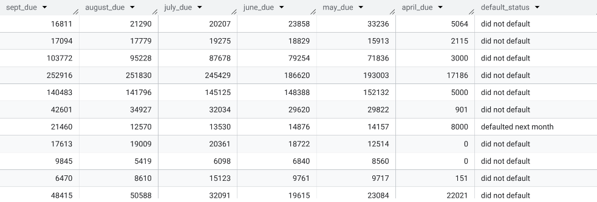

4.Risk Profiling by Demographics

4.1 Analyzing Default Rates by Education and Marriage

SELECT
education_status,
marriage_status,
COUNT(id) AS total_customers,
ROUND(AVG(CASE WHEN default_status = 'defaulted next month' THEN 1 ELSE 0 END)*100,2) AS portfolio_default_rate
FROM `credit_risk.customer_risk`
GROUP BY education_status, marriage_status
ORDER BY portfolio_default_rate DESC;

Output:

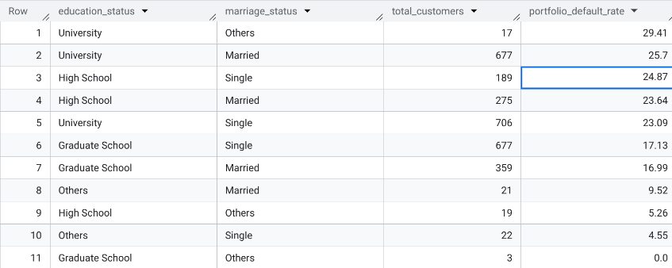

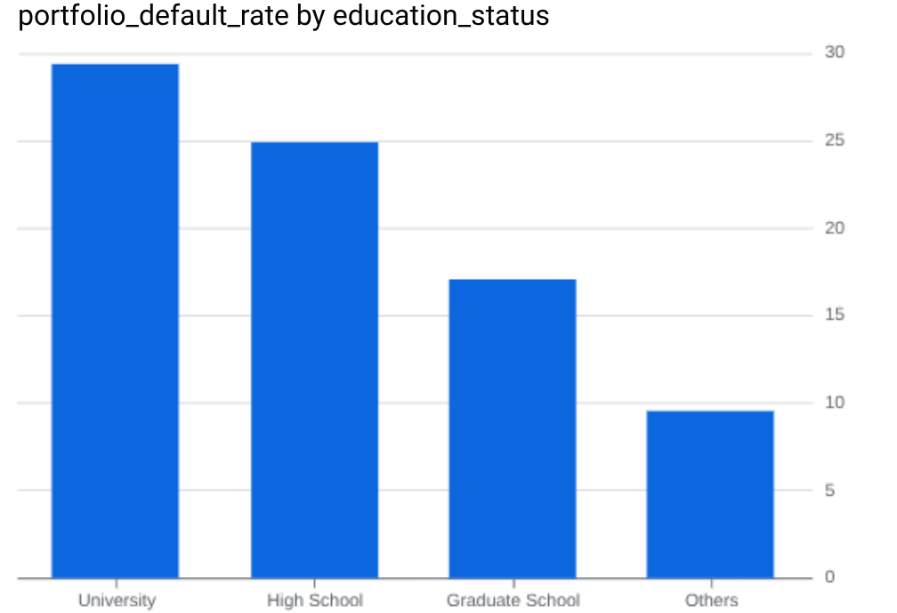

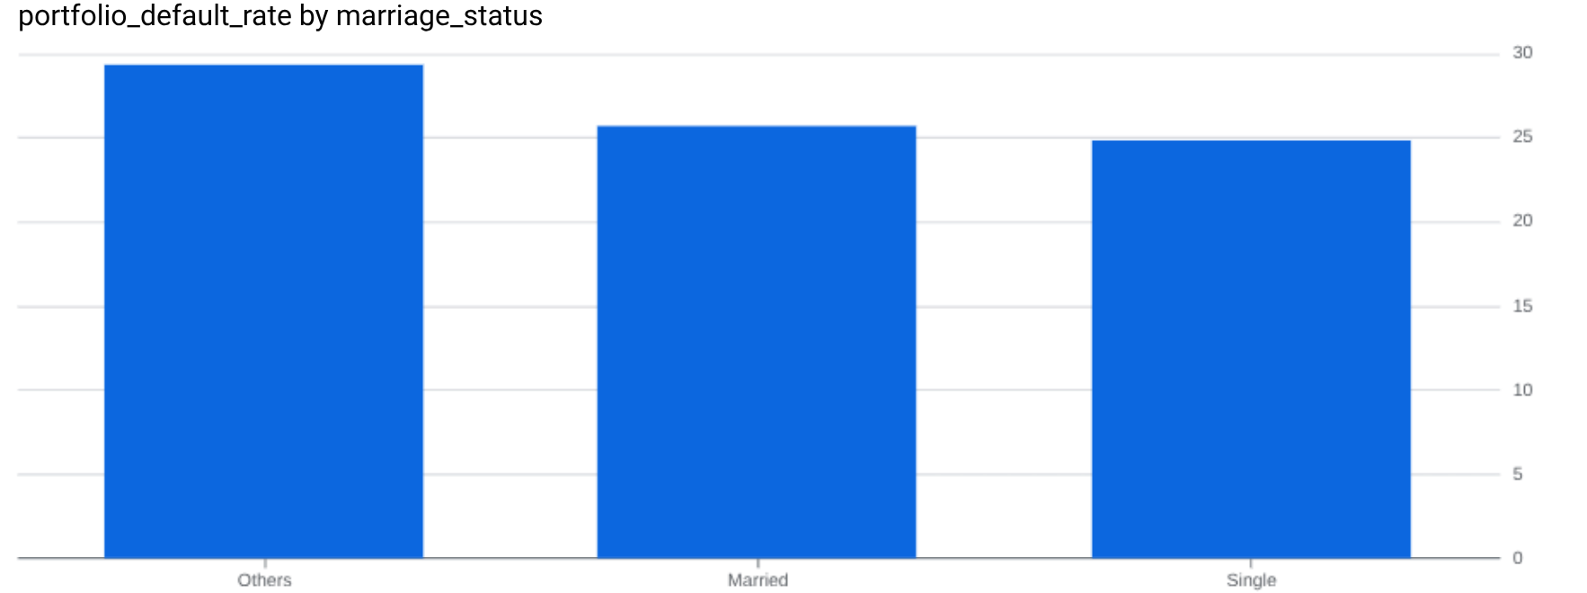

Insight
- Education is the strongest predictor of default risk.
- Borrowers with High School and University education have the highest default rates 29% and together constitute 47.22% of the database
- High School customers consistently exhibit default rates above 23%, materially higher than Graduates , who have the lowest default risk and form only 18.65% of the database.
- Marital status provides secondary stabilisation.
- On average, Married and Single customers are at par across education groups (inter-disciplinary);
- However, within the same education category (intra-disciplinary), Married customers are less likely to default than Singles.
- The lowest-risk segment is Married Graduate School customers 17%, while the highest-risk segment is Unmarried High School customers 25%.
- Graduate School customers form the most stable segment.
- Extremely high default rates in “Others” categories are statistically unreliable due to very low sample

4.2 Risk by Education & Age

SELECT
age_category,
education_status,
COUNT(*) as total_customers,
ROUND(AVG(CASE WHEN default_status = 'defaulted next month' THEN 1 ELSE 0 END)*100,2) AS portfolio_default_rate
FROM `credit_risk.customer_risk`
GROUP BY age_category, education_status
ORDER BY portfolio_default_rate desc;

Output:

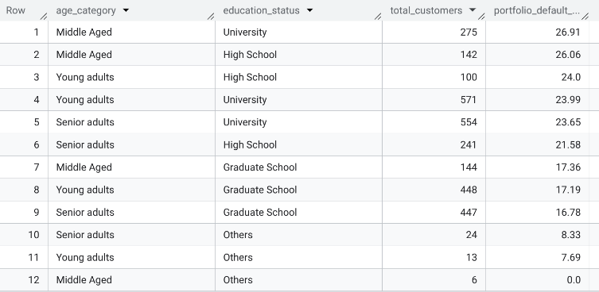

Insight
- Education continues to dominate default behaviour across all age groups.
High School and University customers show default rates in the 23–27% range regardless of age, while Graduate School customers remain near 17% across all age categories.
- Middle-aged borrowers in High School and University segments are the highest-risk cohorts.
Middle-Aged University: 26.91%
Middle-Aged High School: 26.06%
- Age has limited standalone impact.
Within each education group, default rates remain broadly stable across Young, Middle-Aged, and Senior cohorts, indicating that age is a weak discriminator once education is controlled for.
- Graduate School customers are consistently low-risk across the lifecycle.
Default rates stay tightly clustered around 16.8–17.4%, making this group the most reliable portfolio segment.
“Others” education categories are statistically insignificant and excluded from policy decisions.

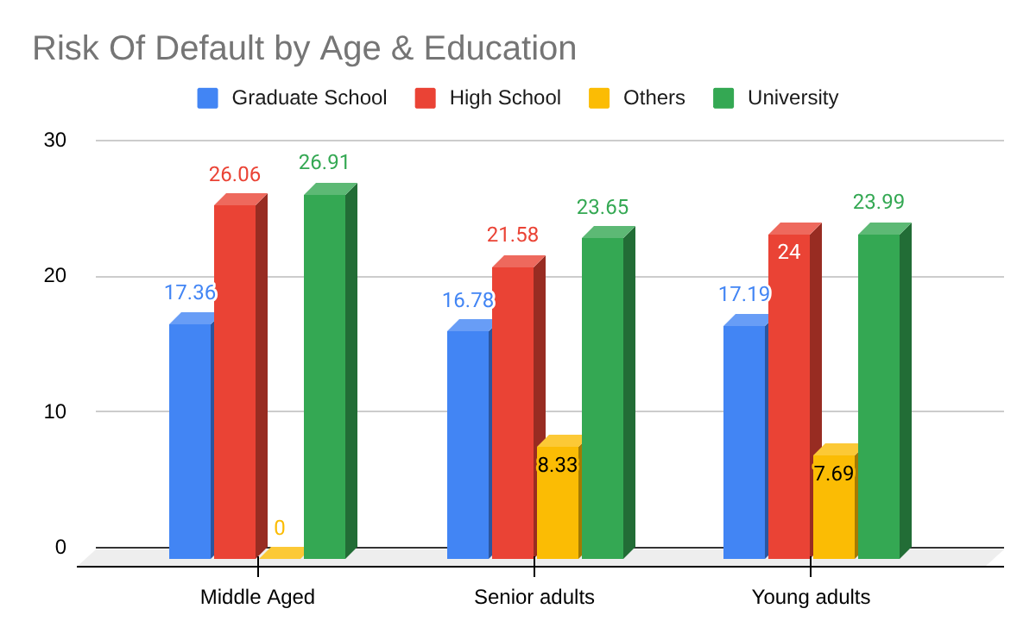

4.3 Risk by Age & Gender

SELECT
age_category,
gender,
COUNT(*) as total_customers,
ROUND(AVG(CASE WHEN default_status = 'defaulted next month' THEN 1 ELSE 0 END)*100,2) AS portfolio_default_rate
FROM `credit_risk.customer_risk`
GROUP BY age_category, gender
ORDER BY portfolio_default_rate desc;

Output:
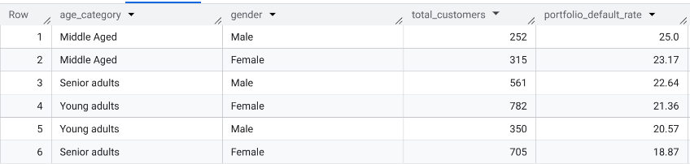

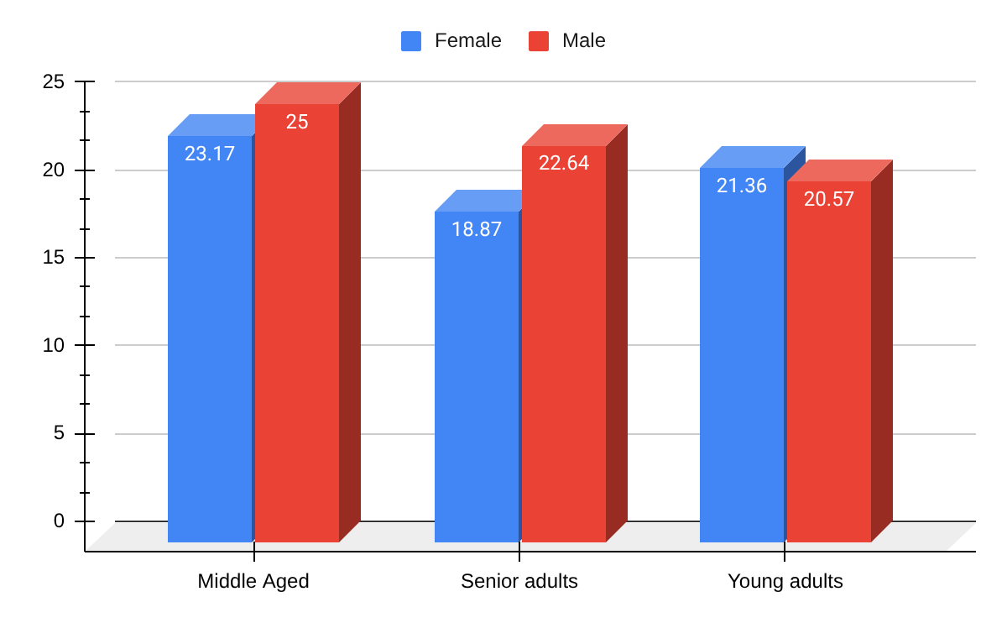

Insight
- Middle-aged males represent the highest-risk demographic, with a default rate of 25%, exceeding all other age gender cohorts.
Males consistently underperform females within the same age group.
- Middle-Aged: 25.0% (Male) vs 23.2% (Female)
- Young Adults: 20.6% (Male) vs 21.4% (Female marginal difference)
- Senior Adults: 22.6% (Male) vs 18.9% (Female)
- Senior adult females form the most stable large segment, showing the lowest default rate (18.9%) over a sizable base.
- Age alone is not a strong predictor; risk is materially amplified when combined with male gender, particularly in the middle-aged cohort.

4.4 Risk By Education & Gender

SELECT
gender,
education_status,
COUNT(*) as total_customers,
ROUND(AVG(CASE WHEN default_status = 'defaulted next month' THEN 1 ELSE 0 END)*100,2) AS portfolio_default_rate
FROM `credit_risk.customer_risk`
GROUP BY gender, education_status
ORDER BY portfolio_default_rate desc;

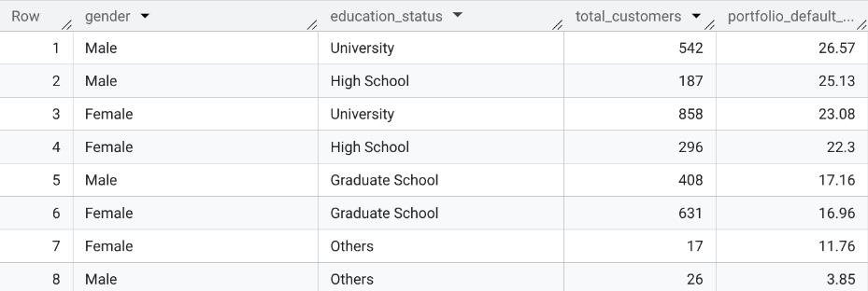
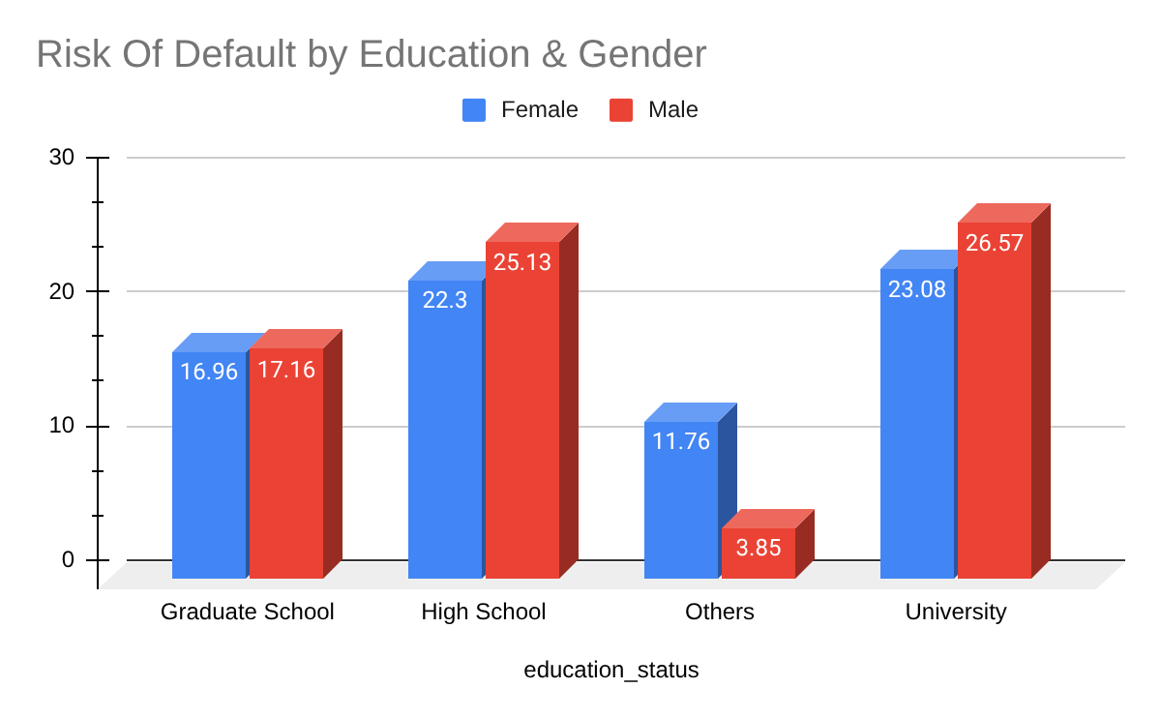
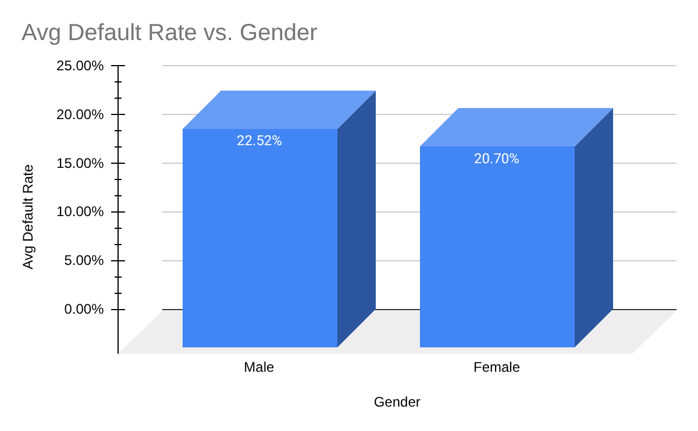

Insight
- Education remains the dominant risk driver.
University and High School customers show default rates above 22–26% across both genders, while Graduate School customers remain near 17%.
- Male customers are consistently riskier within each education band.
Males record higher default rates than females in University (26.6% vs 23.1%), High School (25.1% vs 22.3%), whereas Graduate School (17.2% vs 17.0%) segments more or less equal.
- University educated males have the highest percentage to default, with a default rate of 26.6% consisting around 19% of our database.
- Database has highest no. of Female University scholars having 3rd largest percentage to default around 23.08% runner up after male high schoolers with 25% likelihood to default .
- “Others” education categories are excluded from policy use due to negligible volumes and unstable rates.

‘Across demographic dimensions, education consistently dominates default behaviour, while age and gender act as secondary amplifiers rather than primary drivers.’

5. Behavioural Risk & Delinquency Analytics

5.1 Credit Utilization Ratio
$Credit Utilization ratio =( Total Credit Outstanding ÷ Total Limit Balance )*100$

SELECT
CASE
WHEN (sept_due+august_due+july_due+june_due+may_due+april_due)/limit_balance < 0.3 THEN 'Low'
WHEN (sept_due+august_due+july_due+june_due+may_due+april_due)/limit_balance BETWEEN 0.3 AND 0.7 THEN 'Medium'
ELSE 'High'
END AS utilisation_band,
gender,
age_category,
CASE
WHEN limit_balance < 50000 THEN 'Low Limit'
WHEN limit_balance BETWEEN 50000 AND 200000 THEN 'Medium Limit'
ELSE 'High Limit'
END AS limit_band,

COUNT(*) AS customers,
ROUND(AVG(CASE WHEN default_status='defaulted next month' THEN 1 ELSE 0 END)*100,2) AS default_rate

FROM credit_risk.customer_risk
GROUP BY utilisation_band, gender, age_category, limit_band;

Output
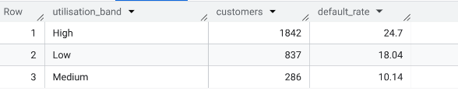

5.1.1 Creating Risk Bands for Each Category

SELECT
CASE
WHEN (sept_due+august_due+july_due+june_due+may_due+april_due)/limit_balance < 0.3 THEN 'Low'
WHEN (sept_due+august_due+july_due+june_due+may_due+april_due)/limit_balance BETWEEN 0.3 AND 0.7 THEN 'Medium'
ELSE 'High'
END AS utilisation_band,
gender,
age_category,
CASE
WHEN limit_balance < 50000 THEN 'Low Limit'
WHEN limit_balance BETWEEN 50000 AND 200000 THEN 'Medium Limit'
ELSE 'High Limit'
END AS limit_band,
COUNT(*) AS customers,
ROUND(AVG(CASE WHEN default_status='defaulted next month' THEN 1 ELSE 0 END)*100,2) AS default_rate
FROM credit_risk.customer_risk
GROUP BY utilisation_band, gender, age_category, limit_band;

Output:
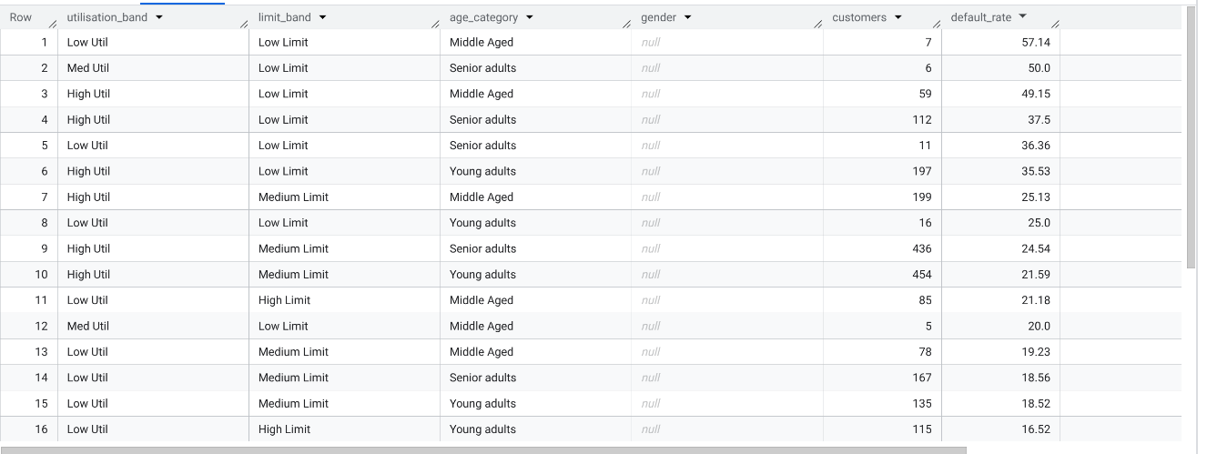

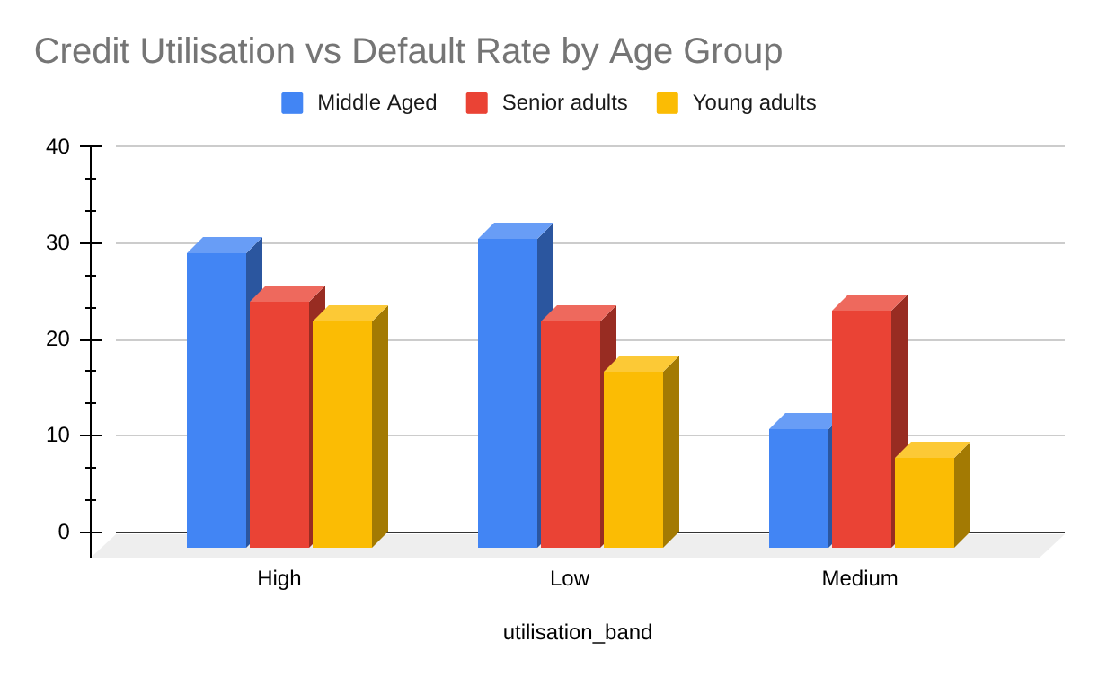

Insight
- Middle-aged customers are the riskiest cohort across utilisation bands.
They record the highest default rates in both the High (30%) and Low (32%) utilisation segments, indicating elevated baseline credit stress relative to Young and Senior adults.
- Young adults consistently exhibit the lowest default risk, particularly in the Medium utilisation band (9%), reflecting better short-term repayment behaviour at moderate utilisation levels
- Senior adults show intermediate risk, with default rates rising sharply in the High utilisation band (25%), confirming sensitivity to elevated credit dependency later in the lifecycle with risk aversion behaviour.
- The pronounced drop in default rates in the Medium utilisation band across all age groups highlights a stable operating zone, where customers maintain manageable credit usage and exhibit materially lower default propensity.
- Hence, Middle-aged customers operating at high or very low utilisation should be prioritised for behavioural monitoring, while medium utilisation customers represent the most stable servicing segment across the lifecycle.

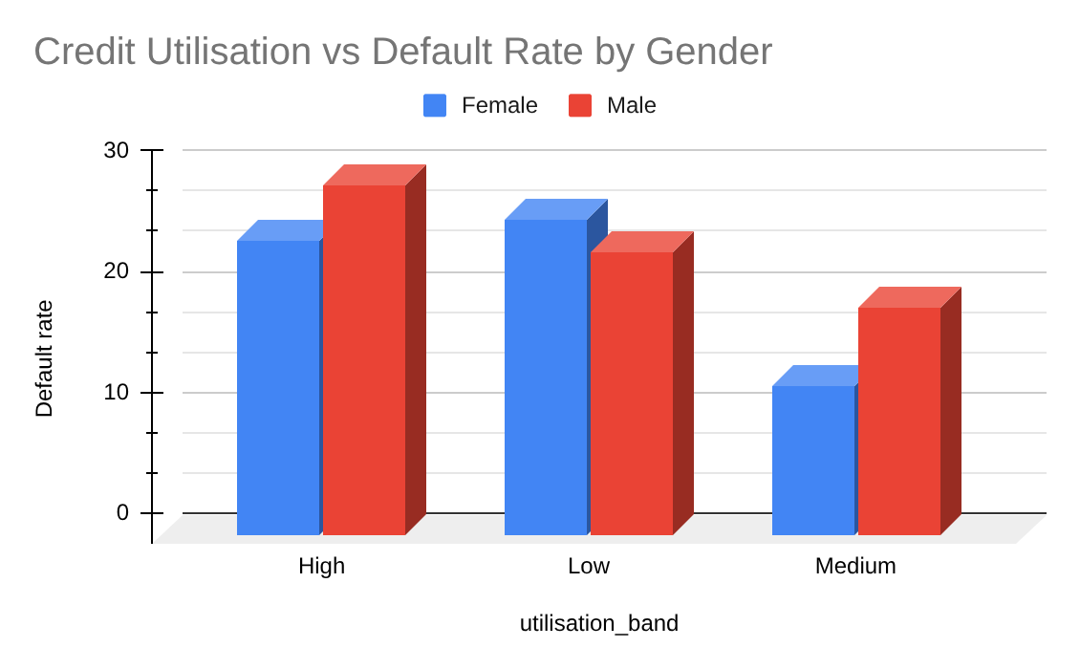

Insight
- Male customers consistently exhibit higher default rates than females across all utilisation bands.
- The risk gap is widest in the High utilisation segment, confirming that financial stress amplifies gender based risk differentials.
- Even at Medium utilisation, males remain materially riskier, while females demonstrate stronger repayment behaviour.
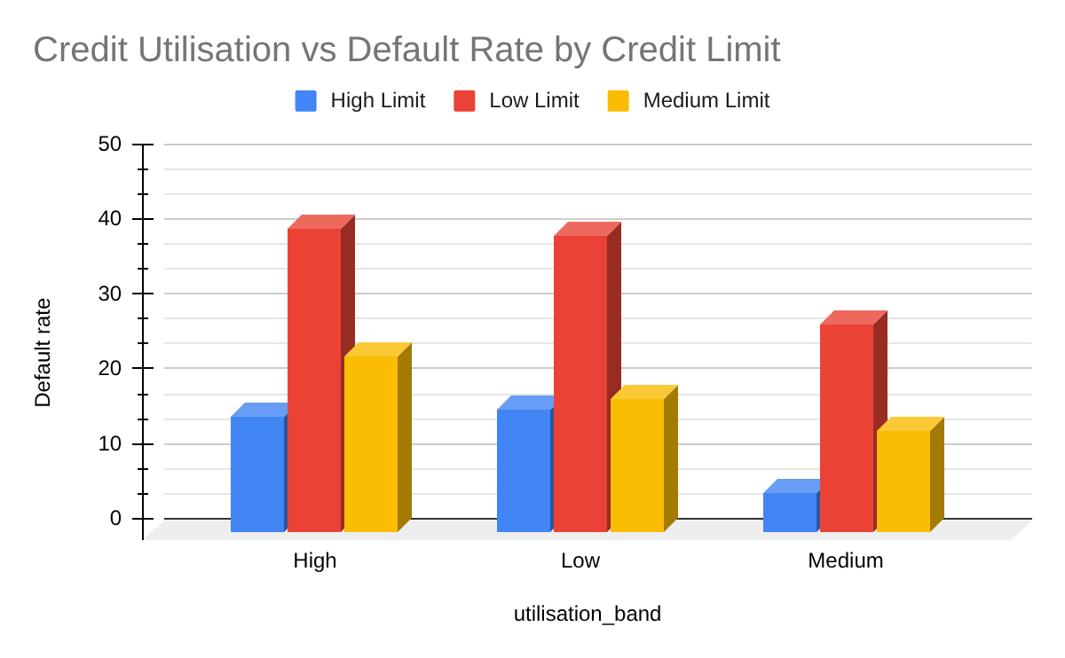
- Hence, Gender acts as a meaningful secondary risk driver, with high utilisation male customers forming a priority early warning segment.

Insight
- Low limit customers exhibit the highest default rates across all utilisation bands, with default exceeding (40% )
- High-limit customers remain the lowest-risk group indicating stronger repayment capacity.
- The sharp contrast between Low and High limit cohorts confirms that credit limit size is a strong proxy for borrower quality and financial resilience.
- Hence, High utilisation combined with low credit limits defines the highest risk loss concentration segment and should be prioritised for exposure control and early collections.

5.2 Delinquency Intensity Score
SELECT
delinquency_intensity,
COUNT(*) AS total_customers,
ROUND(AVG(default_payment_next_month) * 100, 2) AS default_rate
FROM (
SELECT
id,
IF(pay_0 > 0, 1, 0) +
IF(pay_2 > 0, 1, 0) +
IF(pay_3 > 0, 1, 0) +
IF(pay_4 > 0, 1, 0) +
IF(pay_5 > 0, 1, 0) +
IF(pay_6 > 0, 1, 0) AS delinquency_intensity,
default_payment_next_month
FROM `credit_risk.customer_dataset`
)
GROUP BY delinquency_intensity
ORDER BY delinquency_intensity;
Output
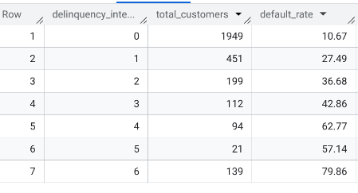
Deliquency | Meaning
0 delays | Perfect payer
1 delay | Minor slippage
2 delays | Emerging risk
3 delays | Chronic stress
4 delays | Severe delinquency
5–6 delays | Near-default
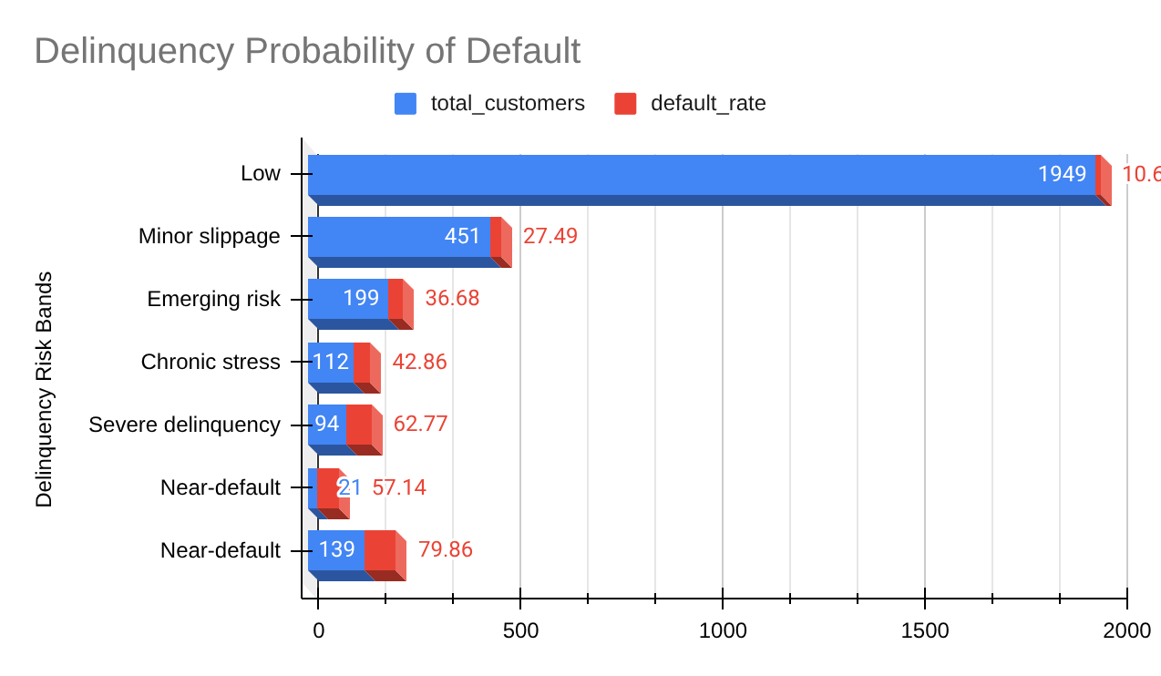

Insight
- The Probability of default shows a clear monotonic increase in default probability as delinquency frequency rises. Customers with no missed payments have the lowest observed PD of around just 10.6 whereas, customers missing payments in 5–6 months exhibit exponentially higher default rates of around 80%.
- About 66% of the portfolio is completely clean, with no delinquencies in the last 6 months.Customers moving from Category 2 & 3 represent the inflection point of financial stress which in our database are around 10% of customers.
• Category 4+ customers should be flagged for pre collection and limit control with 4% of of portfolio.
• Category 6 is operationally indistinguishable from default; these are loss containment candidates consisting of 5% of our portfolio.

5.3 Payment-Discipline Ratio

select
case
when discipline_ratio>= 1 then 'Very healthy'
when discipline_ratio between 0.7 and 1 then 'Stable'
when discipline_ratio between 0.4 and 0.7 then 'Early Stress'
else 'Near default'
end as Discipline_band,
count(*) as customers,
round(avg(default_payment_next_month)*100,2) as default_rate
from (
select
safe_divide(pay_amt_1 + pay_amt_2 + pay_amt_3 + pay_amt_4 + pay_amt_5 + pay_amt_6,bill_amt_1 +bill_amt_2 +bill_amt_3 +bill_amt_4 +bill_amt_5 + bill_amt_6)
as discipline_ratio,
default_payment_next_month
from `credit_risk.customer_dataset`
)
group by discipline_band
order by discipline_band desc;

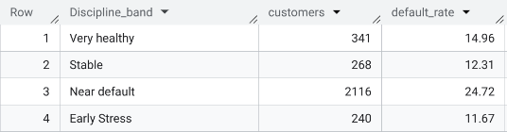

Ratio | Behaviour | Risk Meaning
≥ 1.0 | Pays full dues | Very healthy
0.7 – 1.0 | Pays most of bill | Stable
0.4 – 0.7 | Regular under payment | Early stress
< 0.4 | Chronic under payment | Near default

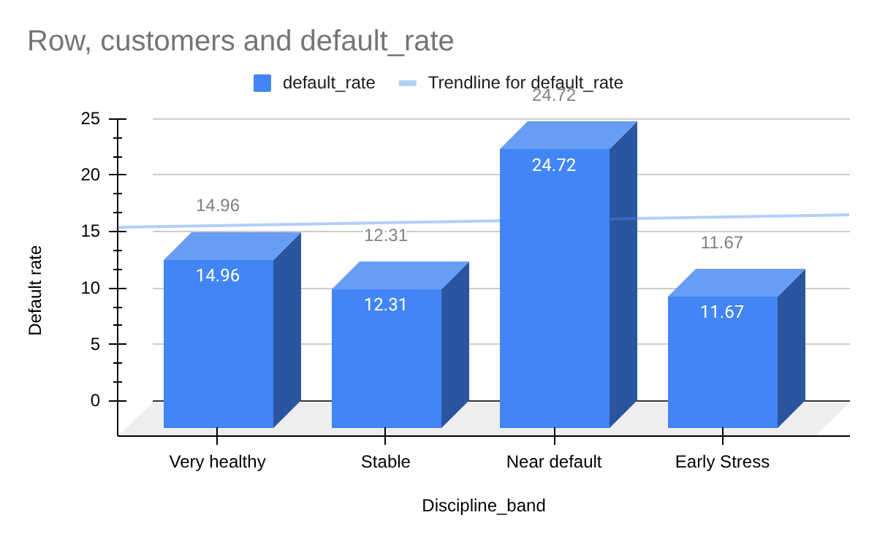

Insight

- Customers with low payment discipline( less than 40%) exhibit materially higher default rates even when not formally delinquent, confirming that chronic under payment is a leading indicator of behavioural credit deterioration. This metric enables proactive identification of silent defaulters before they transition into past-due status.

6. Behavioural Scorecard & Risk Grading

CREATE OR REPLACE VIEW credit_risk.scorecard_record AS
WITH delinquency_table AS (
SELECT
id,
IF(pay_0 > 0,1,0) +
IF(pay_2 > 0,1,0) +
IF(pay_3 > 0,1,0) +
IF(pay_4 > 0,1,0) +
IF(pay_5 > 0,1,0) +
IF(pay_6 > 0,1,0) AS delinquency_6m,

SAFE_DIVIDE(
bill_amt_1 + bill_amt_2+bill_amt_3 +bill_amt_4+ bill_amt_5 + bill_amt_5 + bill_amt_6,
limit_balance
) AS utilisation_ratio,

SAFE_DIVIDE(
pay_0 + pay_2 + pay_3 + pay_4 + pay_5 + pay_6,
bill_amt_1 + bill_amt_2 + bill_amt_3 + bill_amt_4 + bill_amt_5 + bill_amt_6
) AS payment_ratio,

bill_amt_1 AS current_exposure,
default_payment_next_month

FROM credit_risk.customer_dataset
),

scored_customers AS (
SELECT
id,
current_exposure,
default_payment_next_month,

25 * delinquency_6m +
20 * IF(utilisation_ratio > 0.7,1,0) +
15 * IF(payment_ratio < 0.5,1,0) AS risk_score

FROM delinquency_table
)
SELECT
id,
current_exposure,
default_payment_next_month,
risk_score,
CASE
WHEN risk_score < 30 THEN 'A'
WHEN risk_score BETWEEN 30 AND 60 THEN 'B'
WHEN risk_score BETWEEN 60 AND 90 THEN 'C'
ELSE 'D'
END AS risk_grade
FROM scored_customers;

Output:
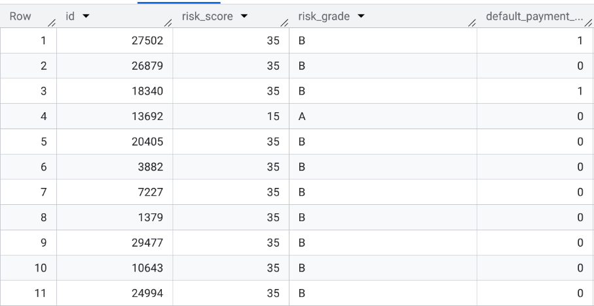

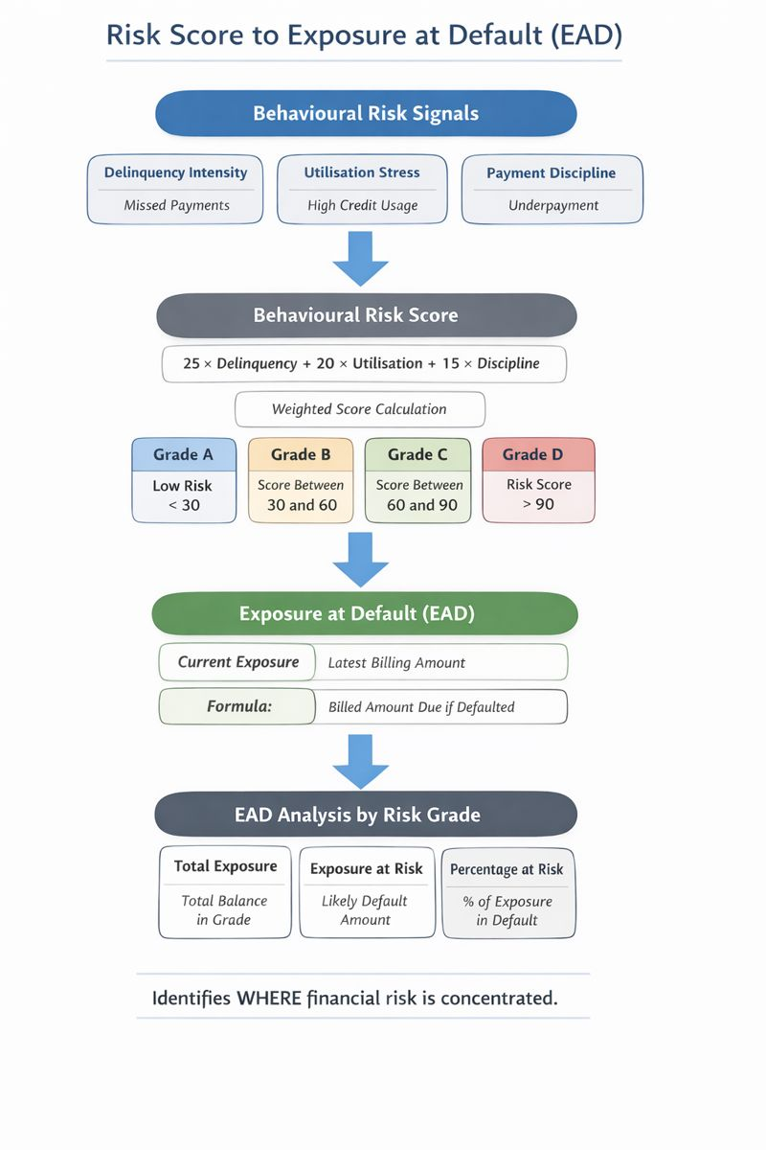

7. Exposure at Default & Value at Risk

select
risk_grade,
sum(current_exposure) as total_exposure,
sum(
case
when default_payment_next_month = 1 then current_exposure
else 0
end
) as exposure_at_risk
from `credit_risk.scorecard_record`
group by risk_grade
order by exposure_at_risk

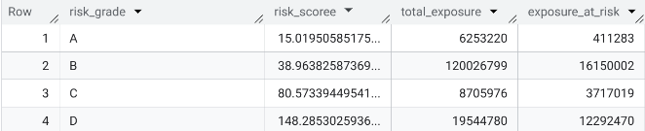

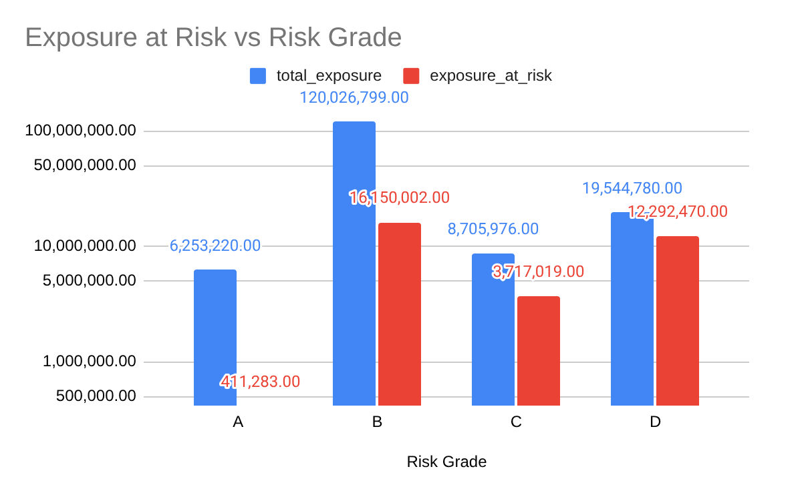

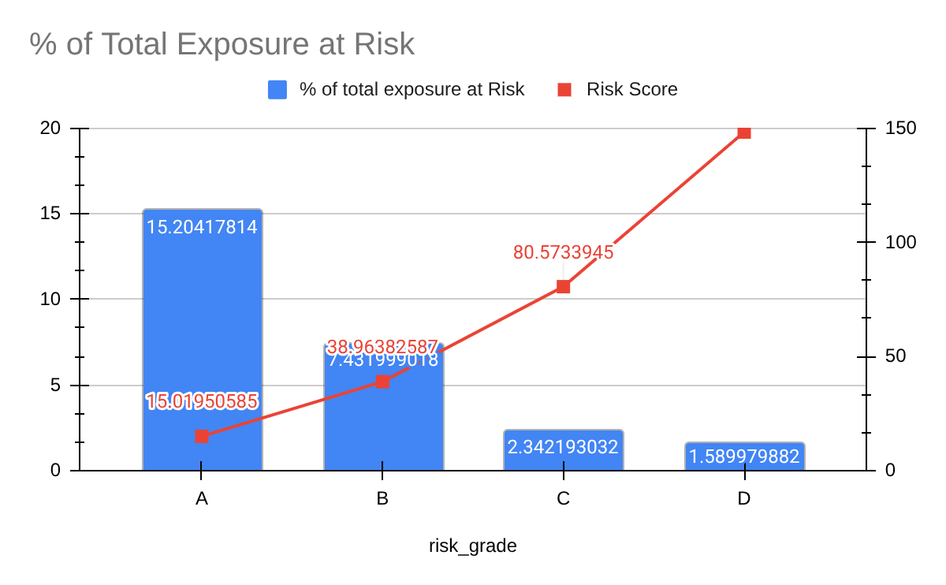

Insight
- Grade A Maintains the lowest average risk score 15% but reflects a 15.2% utilization rate. This suggests that even the safest tier is carrying active debt, warranting monitoring despite low default probability.
- Grade B Holds the maximum concentration with 120M in Total Exposure. It remains a stable revenue pillar, as only 7.4% of its specific category exposure is currently at risk.
- Grade D Exhibits an extreme risk score of 148, indicating chronic delinquency. This segment represents the bank's most severe threat, with a 12.2M corpus currently at risk.
- A critical trend exists where the Percentage at Risk decreases from Grade A to D (15.2% down to 1.5%), yet the Absolute Exposure rises sharply from 411K to 12.2M.

7.1 Customer Count by Risk Grade

select
risk_grade,
count(*) as total_customers,
sum(current_exposure) as total_exposure,
avg(current_exposure) as avg_exposure
from `credit_risk.scorecard_record`
group by risk_grade
order by risk_grade;

Output:
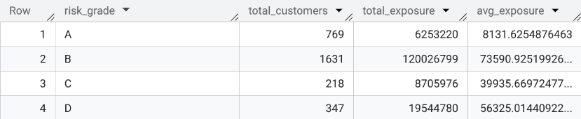

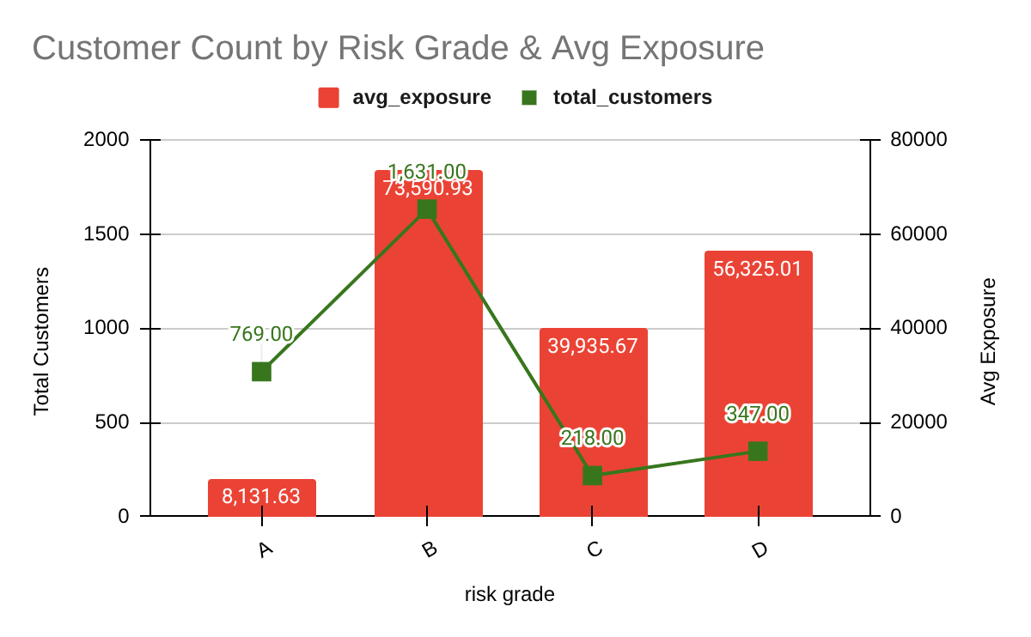

8. Early Warning Signals & Pre-Delinquency Detection
- Rising balances
- Falling payments
- Early stress before default

SELECT
id,
bill_amt_1 AS SEPT_bill,
bill_amt_2 AS AUGUST_bill,
pay_amt_1 AS SEPT_pay,
pay_amt_2 AS AUGUST_pay
FROM `credit_risk.customer_dataset`
WHERE bill_amt_1 > bill_amt_2
AND pay_amt_1 < pay_amt_2
AND pay_0 > 0
ORDER BY (bill_amt_1 - bill_amt_2) DESC
LIMIT 100

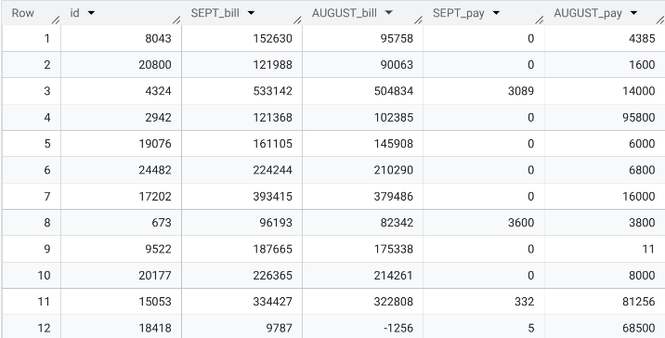

8. Key Insights
- The University segment is the portfolio’s primary risk driver, representing 47.22% of total volume but exhibiting a disproportionately high 29% default rate.
- Borrowers with Graduate School education (18.6% of population) are the most resilient cohort, maintaining a low 17% default floor regardless of marital status or age.
- Education level emerges as the dominant structural risk driver, consistently explaining default behaviour across age, gender, and marital status, while age and gender act as secondary amplifiers rather than primary predictors.
- Analysis of 6 month repayment trends shows that Repayment History is a 1.5x stronger predictor of default than the Credit Limit itself, justifying its high weight in our Risk Scorecard.
- While Grade A customers are the safest, they reflect a 15.2% utilization rate, indicating they are active "revolvers." Conversely, Grade D contains the most toxic debt, with an absolute $12.2M corpus at risk the single largest threat to the bank's liquidity.
- Despite being the "Middle Tier," Grade B holds the largest portfolio volume ($120M), yet only 7.4% of its specific exposure is at risk, making it the bank's most profitable "Anchor" segment.
- The observed decline in percentage exposure at risk across increasing risk grades confirms active exposure containment, indicating a healthy portfolio governance structure rather than a risk management failure.

9. STRATEGIC RISK MITIGATION
- Implement automated transaction blocks on all Grade D accounts (Score >90) while prioritizing aggressive manual collections to safeguard the $12.2M high-risk corpus from further exposure expansion.
- University Segment, Mitigate the 29% default concentration within the portfolio’s largest demographic by tightening Debt-to-Income (DTI) requirements and reducing maximum credit limits for new University category applicants.
- Deploy early warning triggers for Grade B to apply soft credit limit caps on customers showing rising balances and declining repayments, preventing migration into higher risk grades.
- Offset portfolio risk by selectively increasing limits for Graduate segment customers with stable repayment behaviour, capturing low volatility interest income.
- Enhance the monthly credit review engine by integrating"Payment-to-Bill Ratio" to detect liquidity stress and pre delinquency signals 30–60 days before a formal default event occurs.

10. FINAL CONCLUDING STATEMENT
This project successfully bridges the gap between Raw Data and Capital Protection. By utilizing advanced SQL analytics to quantify Exposure at Risk (EaR) and segmenting customers by behavioral and demographic traits, we have moved the bank from a reactive "Wait-and-See" approach to a Proactive Risk Management model.
The primary strategic recommendation is to pivot the bank’s growth strategy toward the Graduate School demographic while aggressively mitigating the $12.2M high-risk tail in Grade D. This dual action plan ensures both the long-term profitability and the financial resilience of the credit portfolio.

